Frontiers in Chemistry
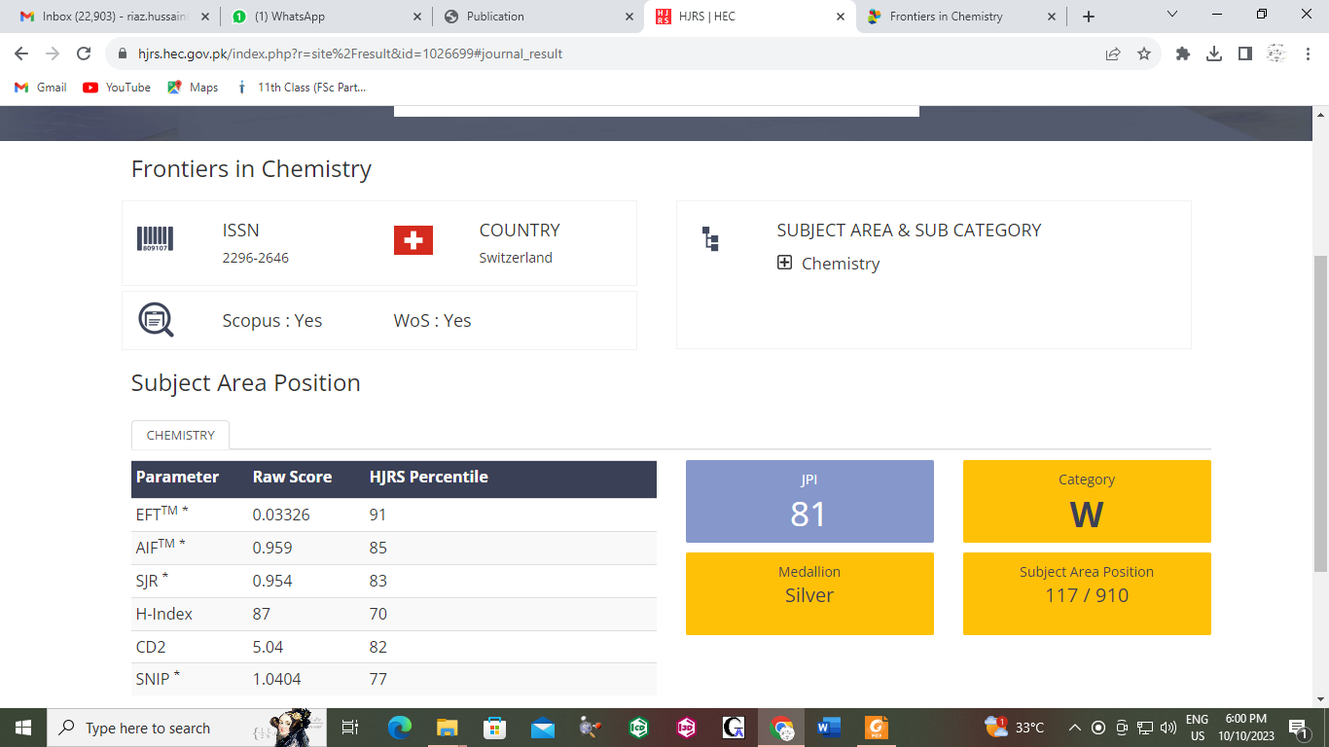
2296-2646

