Molecules
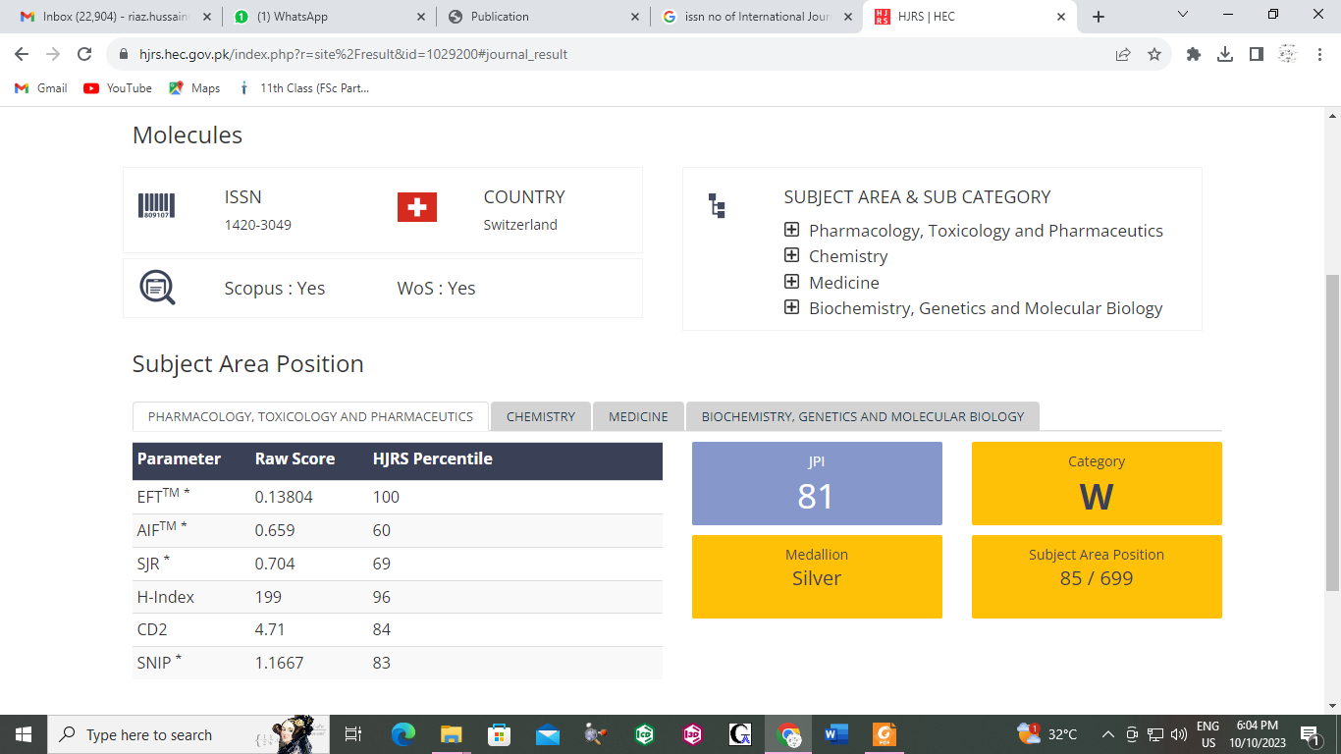
ISSN: 1420-3049

