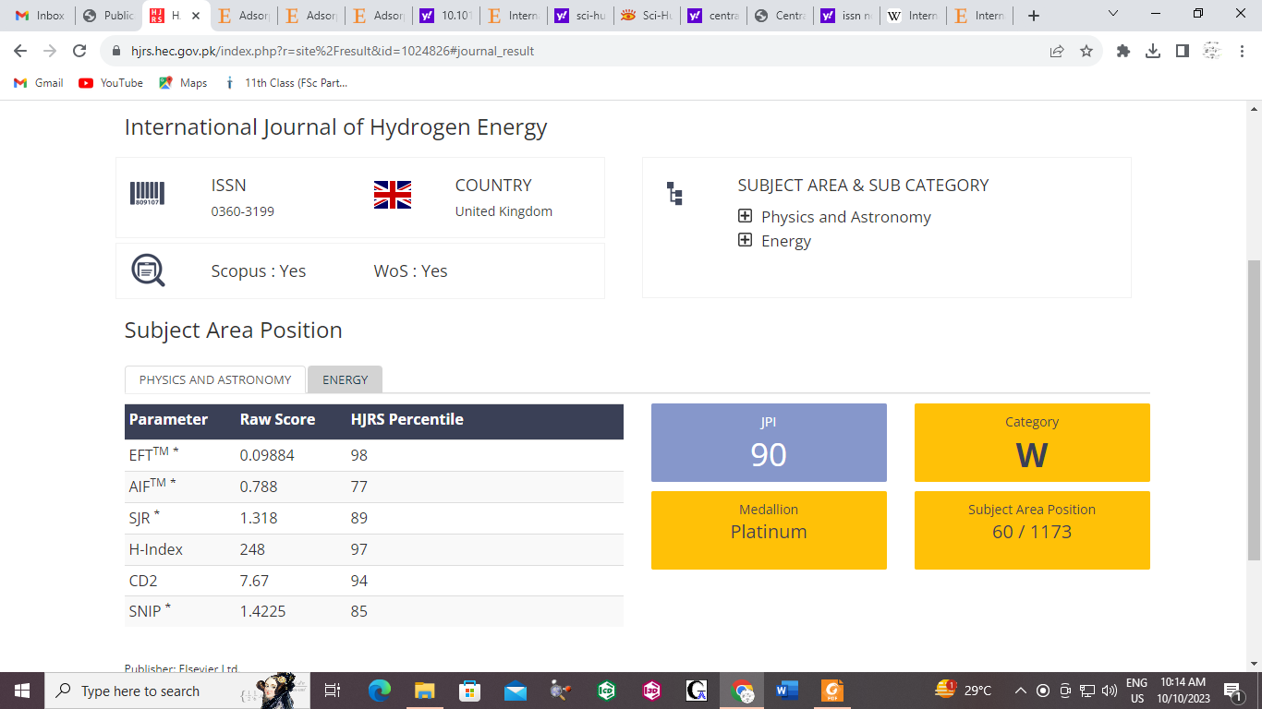
International Journal of Hydrogen Energy

