Journal of Molecular Structure
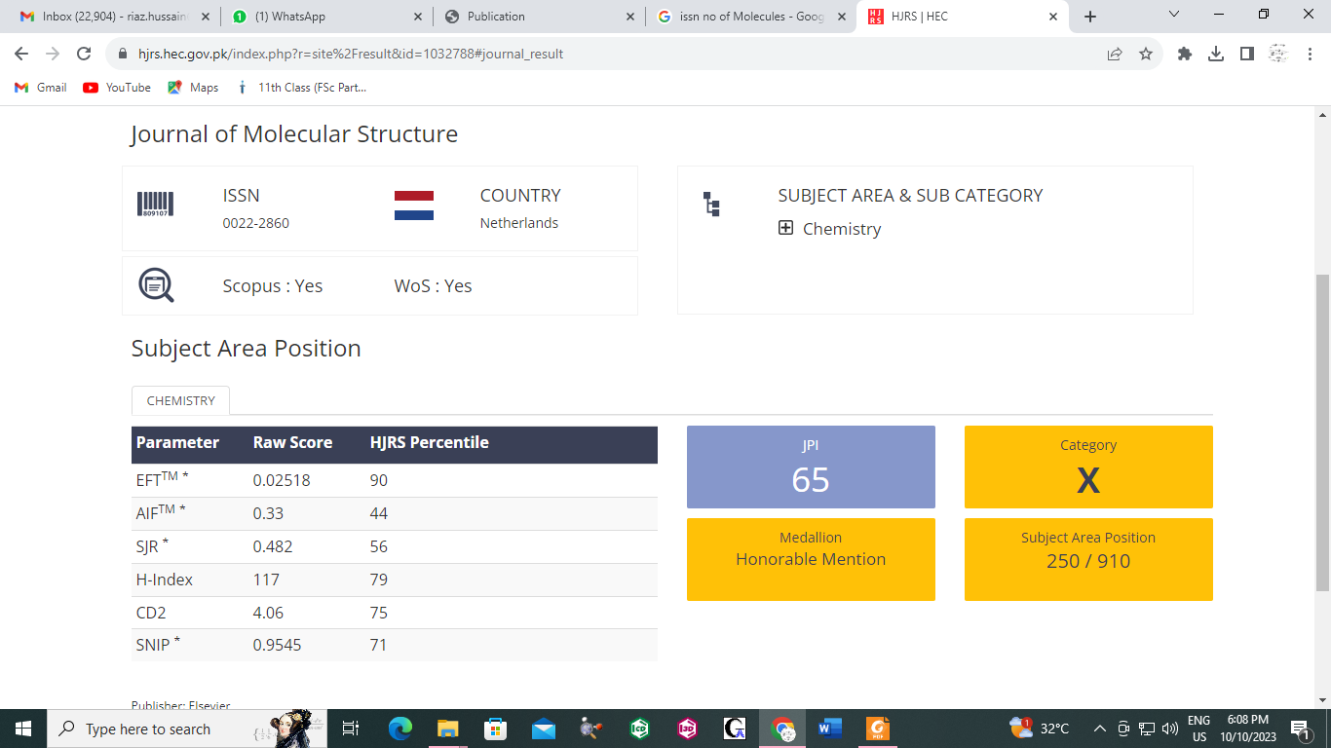
ISSN: 0022-2860

