Link https://hjrs.hec.gov.pk/index.php?r=site%2Fresult&id=1055207#journal_result

2710-4516
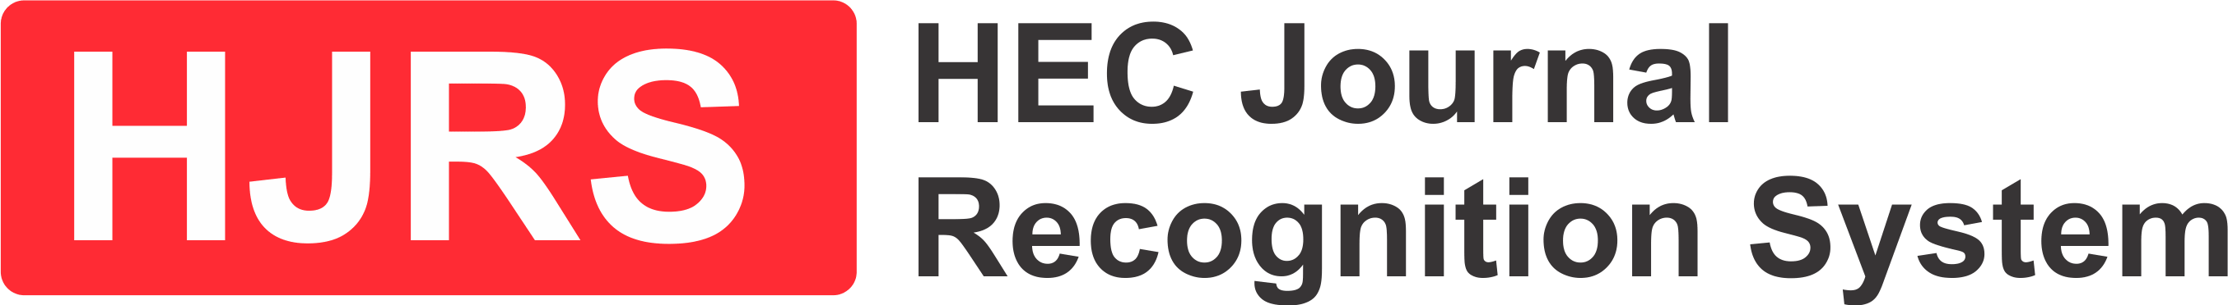
- JOURNAL SEARCH
- DISCIPLINE-WISE SEARCH
- ABOUT HJRS
- FAQs

Journal Search
- JOURNAL NAME
- ISSN

Find Journal

Journal of Interdisciplinary Educational Studies


ISSN

2710-4516

COUNTRY

Pakistan


Scopus : No

WoS : No


SUBJECT AREA & SUB CATEGORY
- Social Sciences

Subject Area Position
- SOCIAL SCIENCES

Parameter | Raw Score | HJRS Percentile
EFTTM * | - | -
AIFTM * | - | -
SJR * | - | -
H-Index | - | -
CD2 | - | -
SNIP * | - | -
JPI-
CategoryY ‡
MedallionNull
Subject Area Position-
Publisher: Lahore College for Women University Lahore
‡ Recognized by HEC Local Committee
* Eigenfactor (EF) and Article Influence (AI) are trademarks of Eigenfactor Project
* SJR is trademark of Scimago Lab
* SNIP is trademark of CWTS
* Above information is based on the data corresponding to year 2023-24
Developed & Maintained by
Login Contact Us

