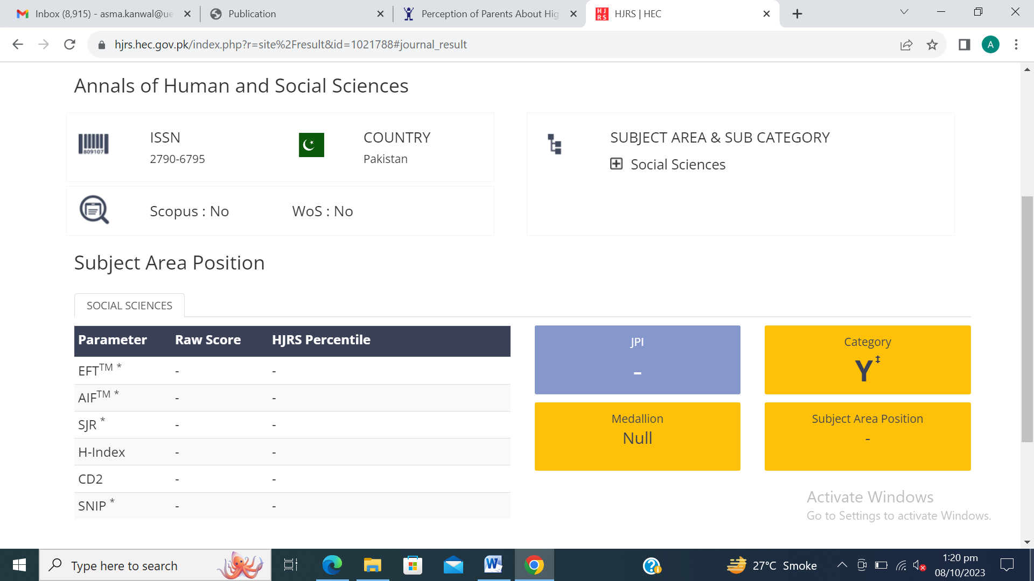

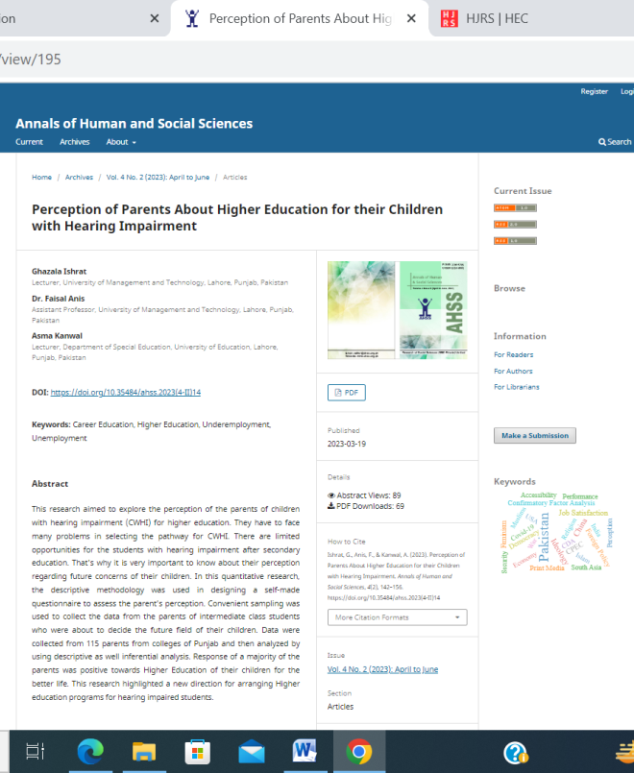
DOI: https://doi.org/10.35484/ahss.2023(4-II)14

