Optical and Quantum Electronics
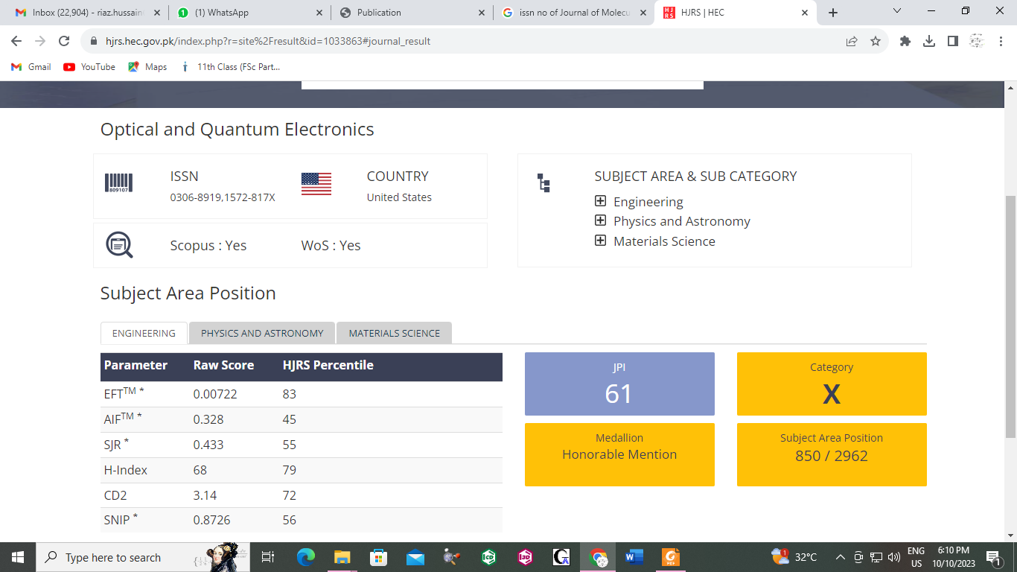
ISSN: 0306-8919

