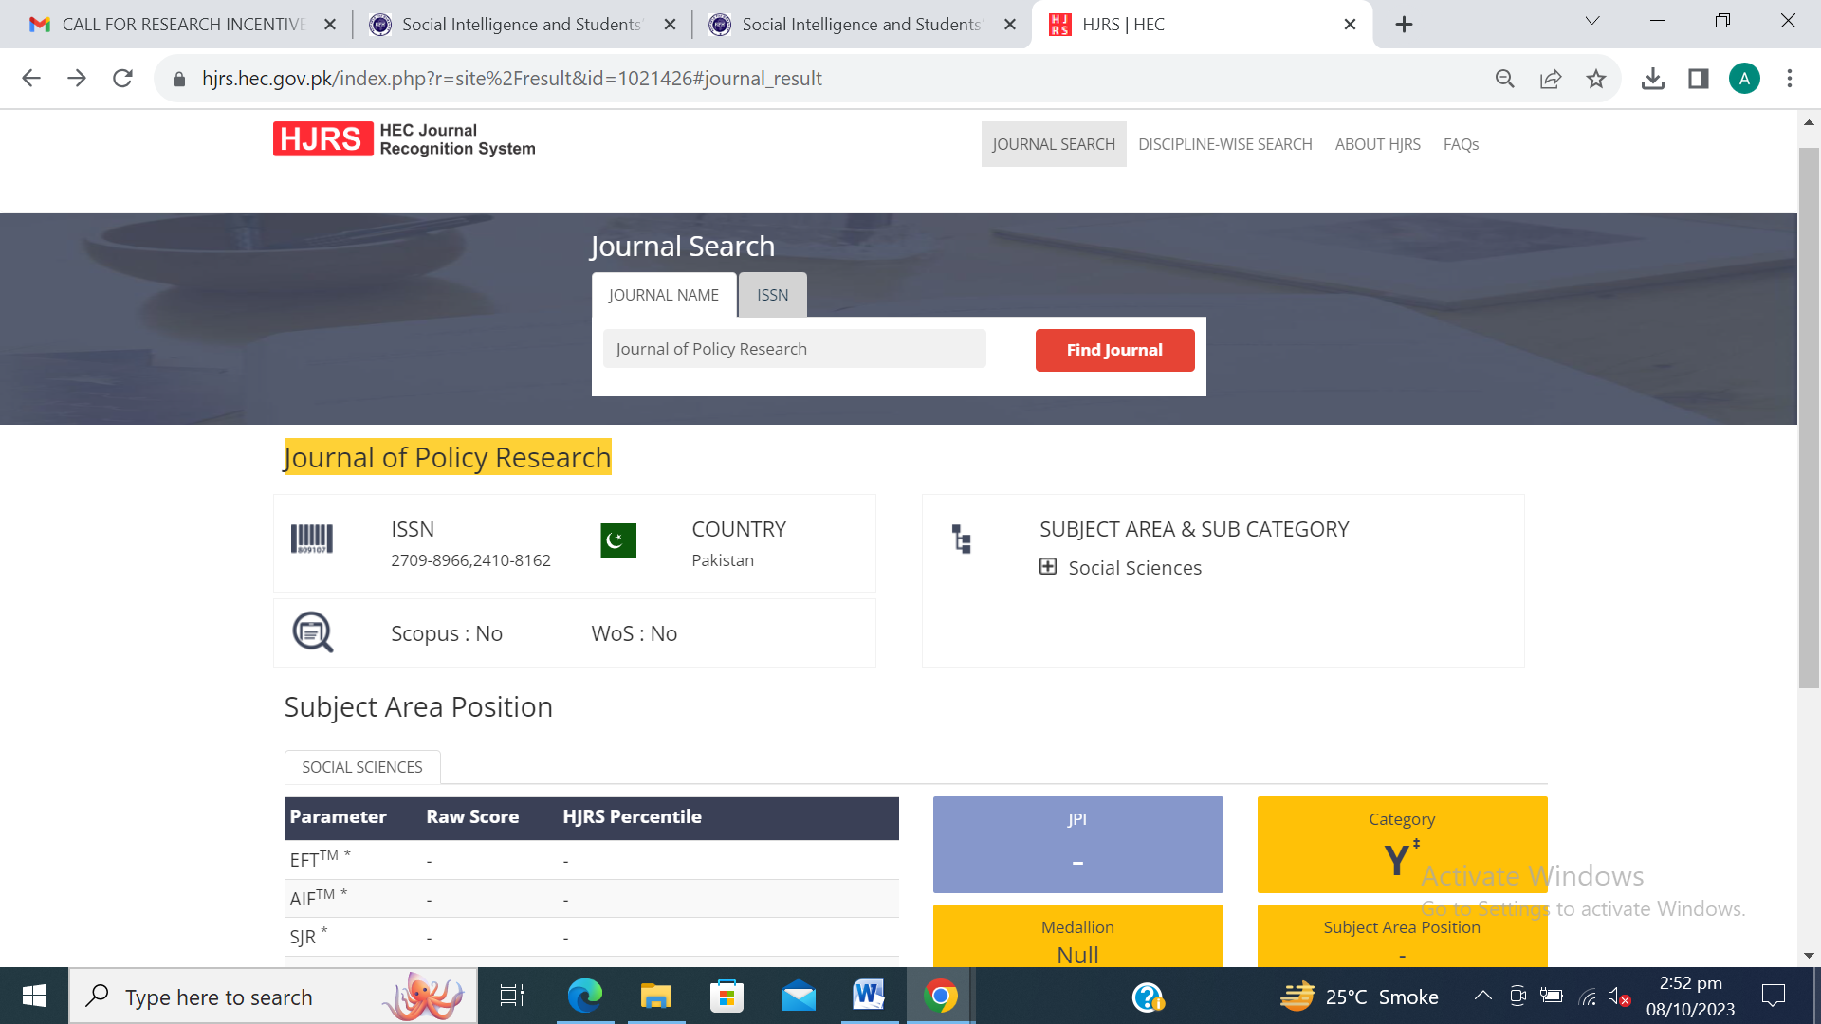

https://jprpk.com/index.php/jpr/article/view/323
https://doi.org/10.5281/zenodo.8251025
