https://hjrs.hec.gov.pk/index.php?r=site%2Fresult&id=1021759#journal_result
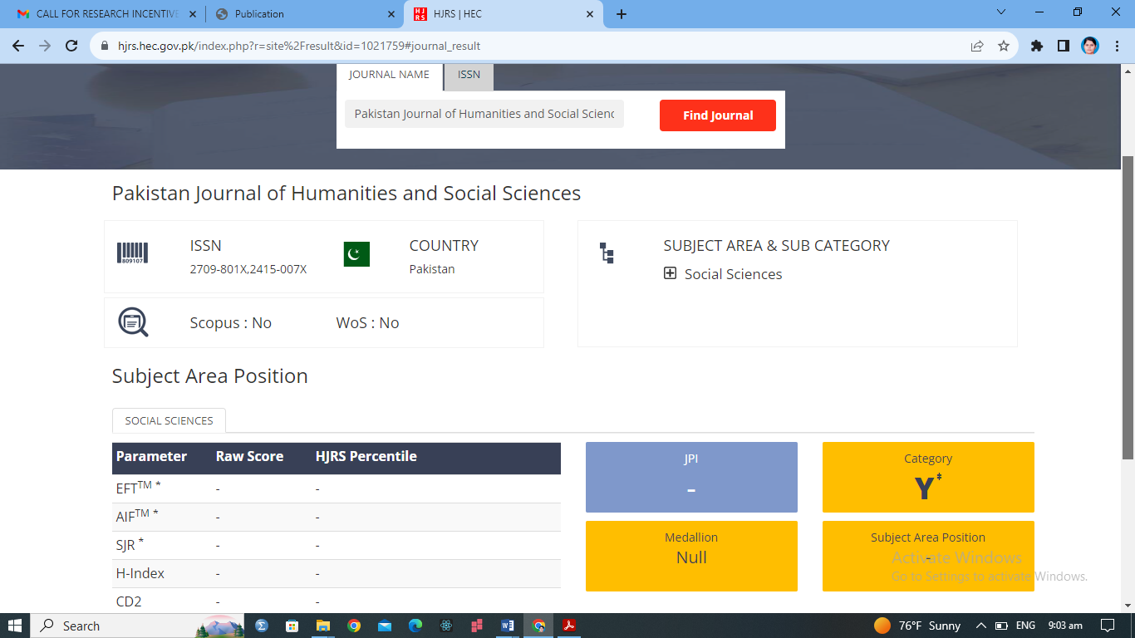
https://journals.internationalrasd.org/index.php/pjhss/article/view/1190
