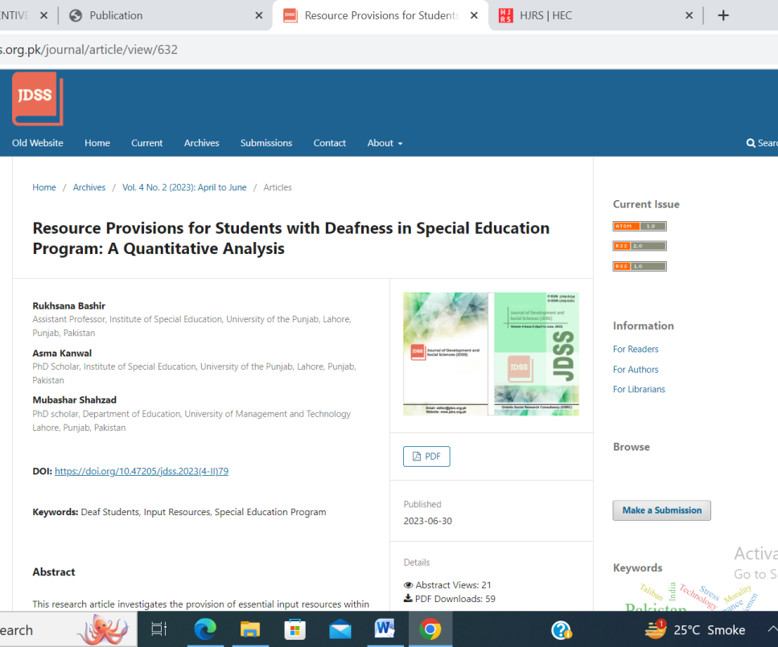

DOI:
https://doi.org/10.47205/jdss.2023(4-II)79
