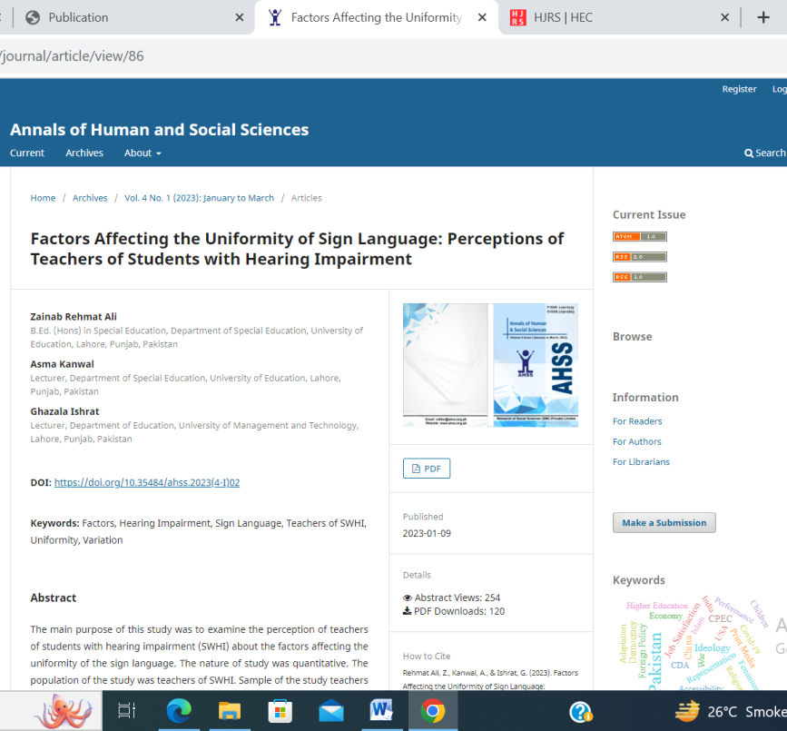

DOI: https://doi.org/10.35484/ahss.2023(4-I)02
