International Journal of Biomaterials
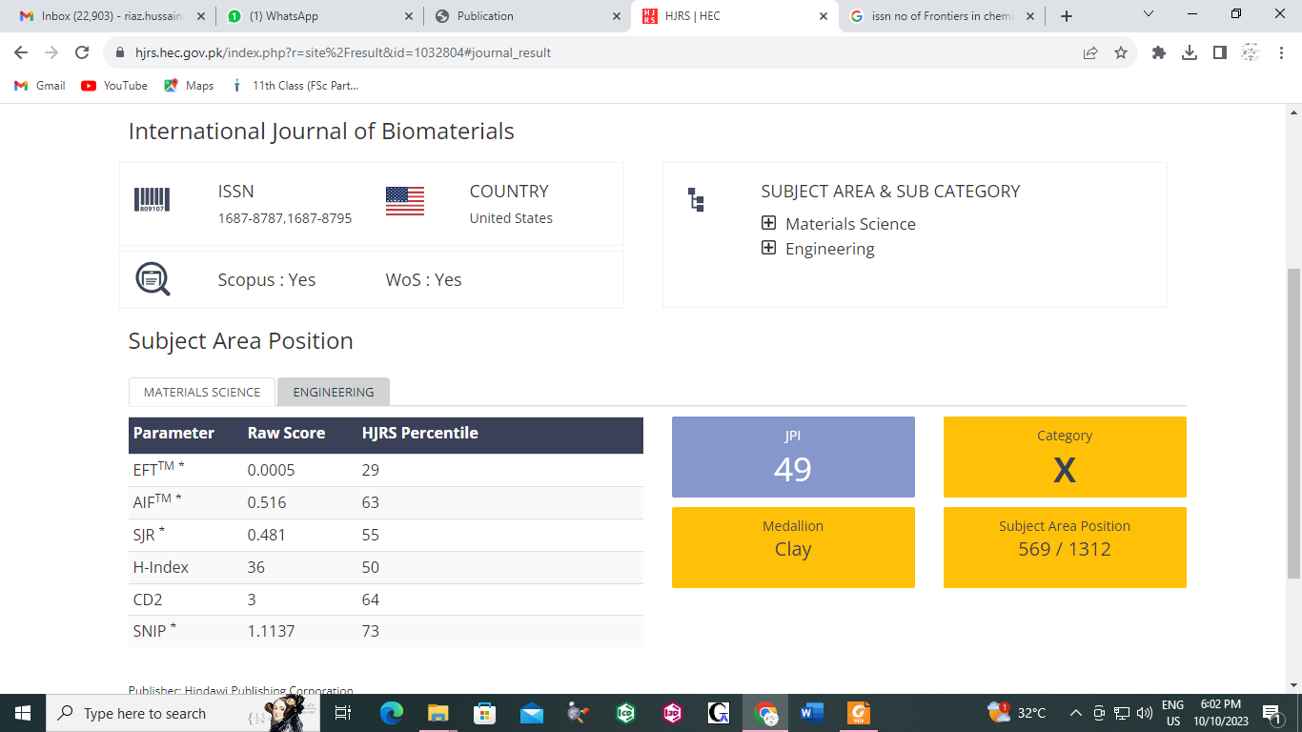
1687-8795

